**Jenkinsfile for CI/CD Pipeline with EKS Deployment for Spring Boot App**

**1:** Create MySQL RDS in US West (Oregon)us-west-2 region

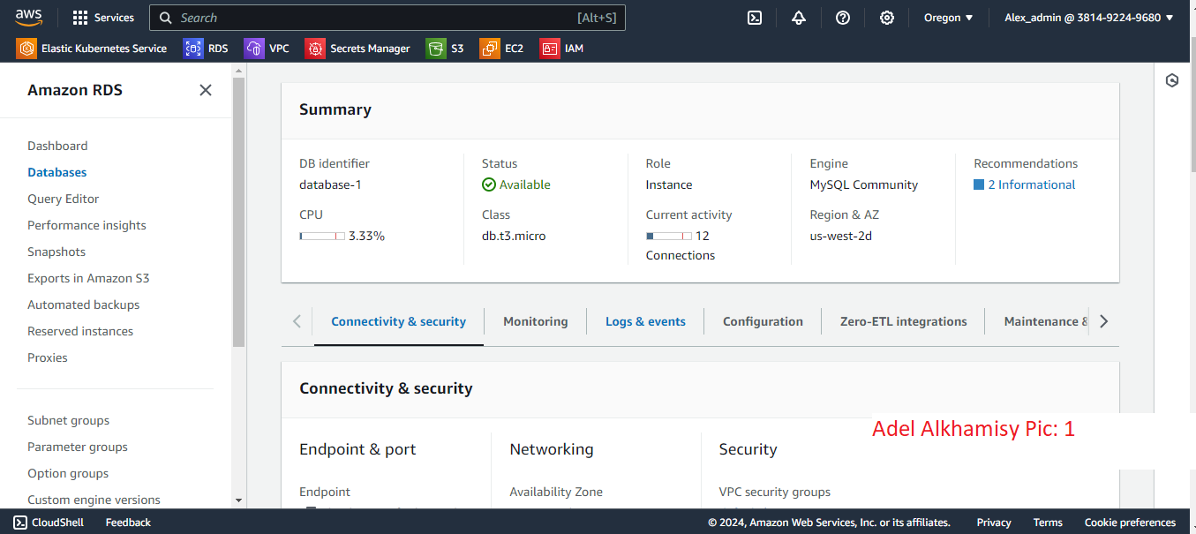

**2:** MySQL RDS configuration

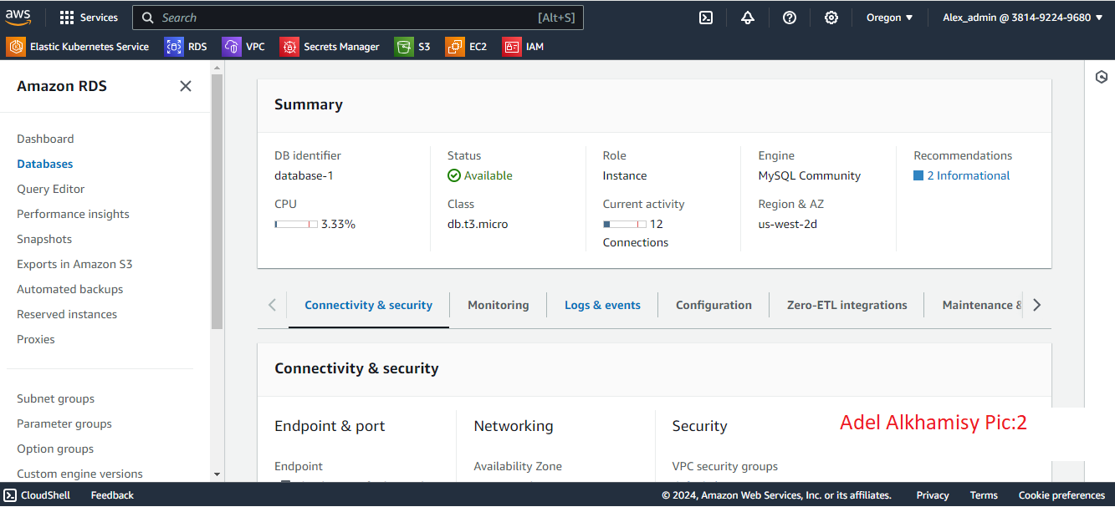

**3:** MySQL Workbench

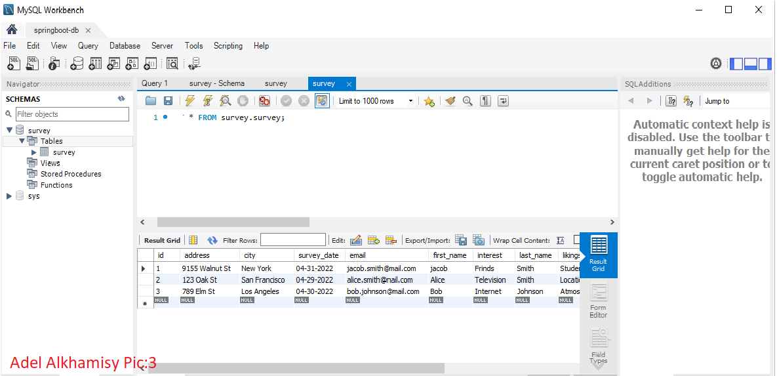

**4:** Create ec2 instance to install Jenkins, docker and maven. In us-east-1 with configuration: 2 vCPU, 4 GB RAM, 20 GB EBS volume

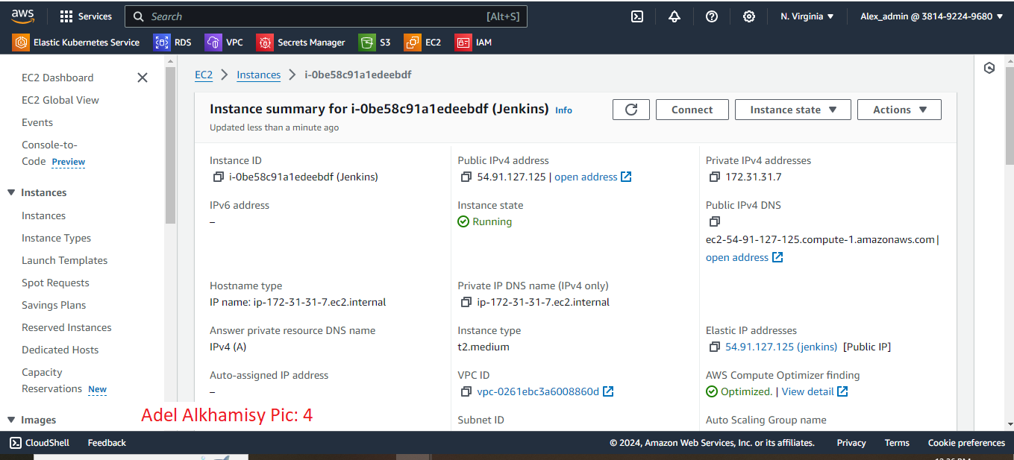

**5:** Ec2 console connect

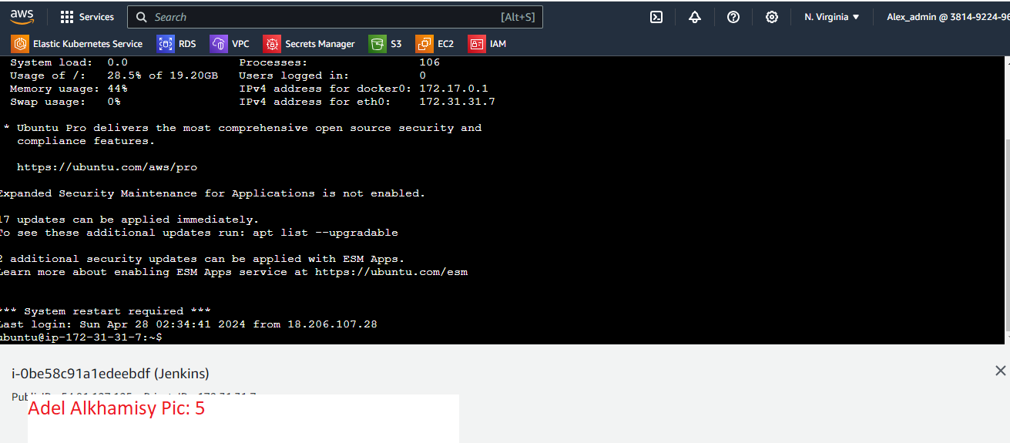

**6.** ECR to manage docker images

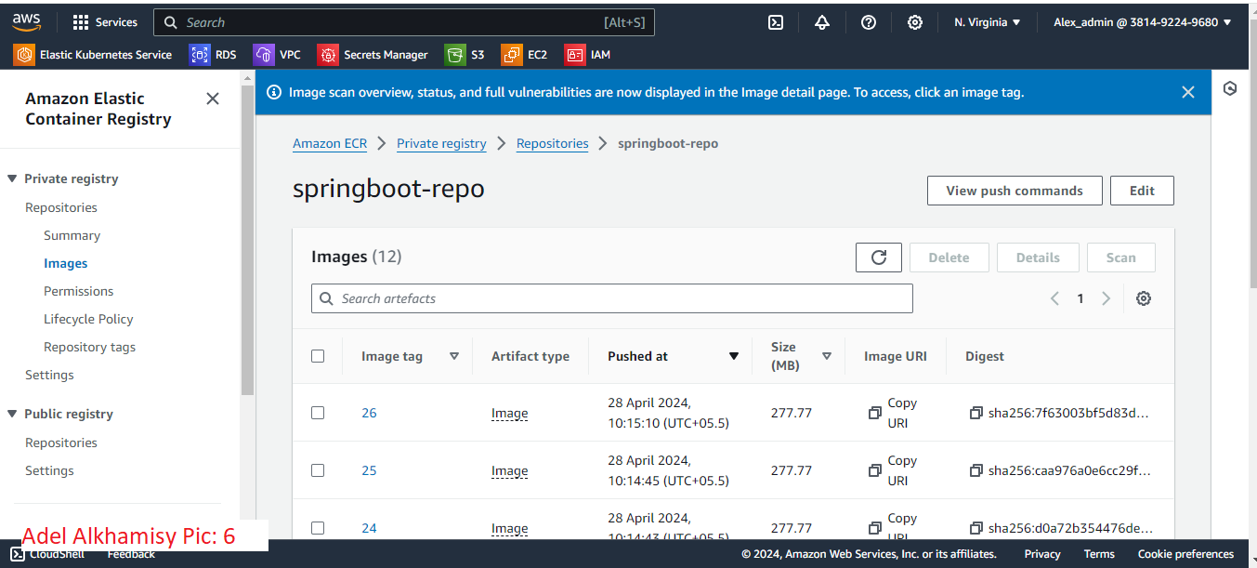

7. Create EKS to deploy springboot app

Configuration: Two node, Instance type for both: t3.small, region: us-east-1

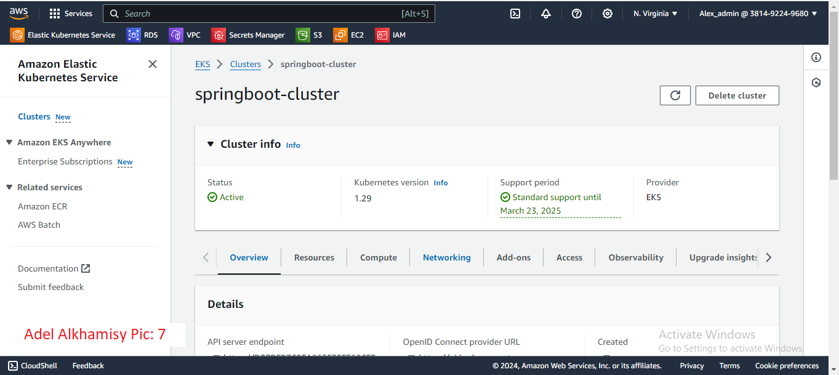

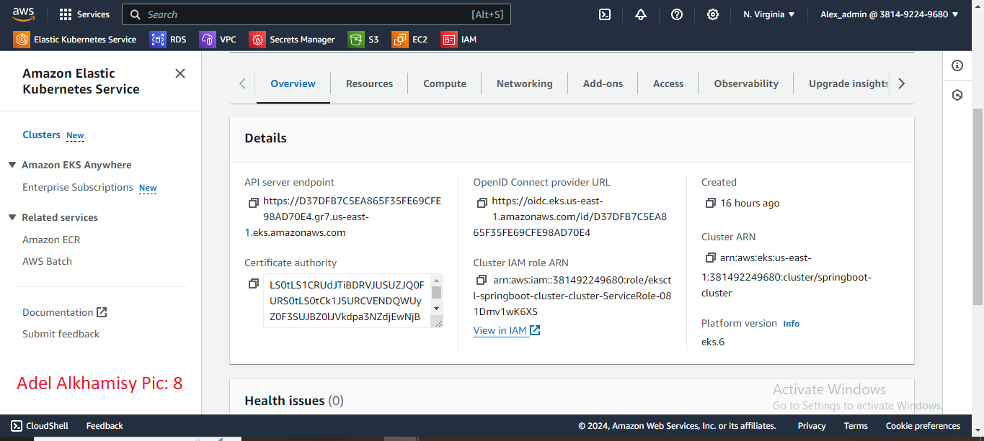

**8.** Create Dockerfile to build image

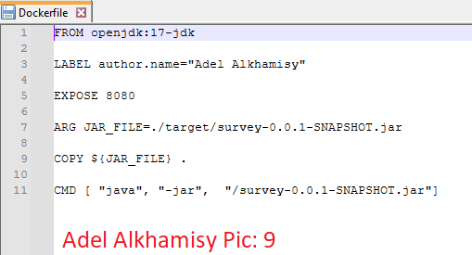

9. Configure Jenkins to build pipeline

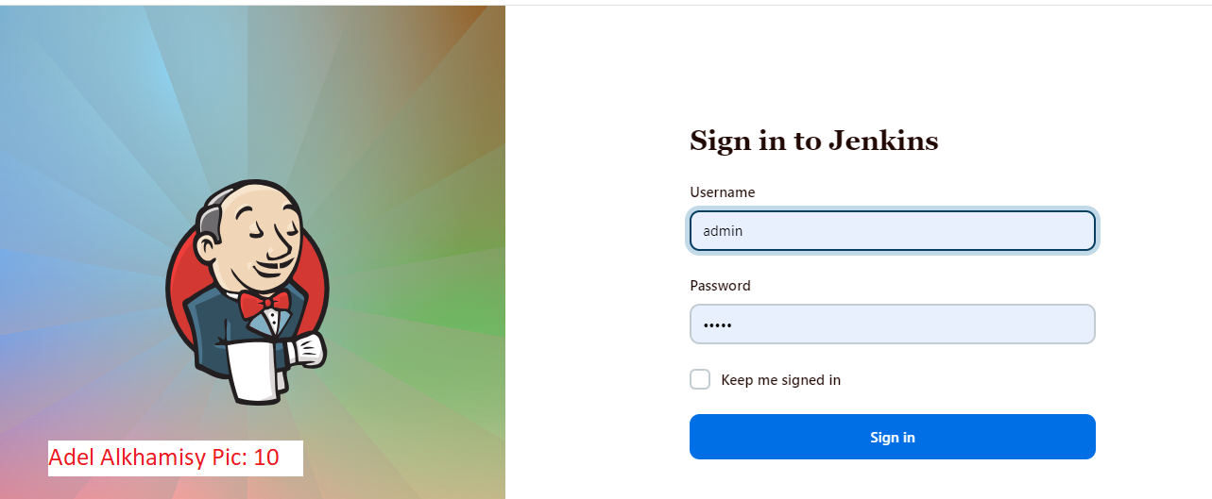

10. Jenkins dashboard

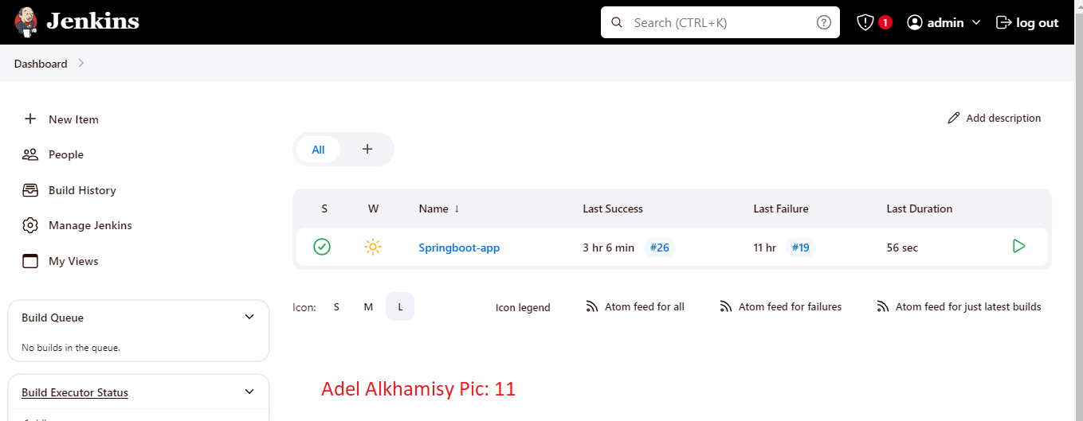

11. Jenkins project configuration. Complete Jenkins file is in GitHub repository

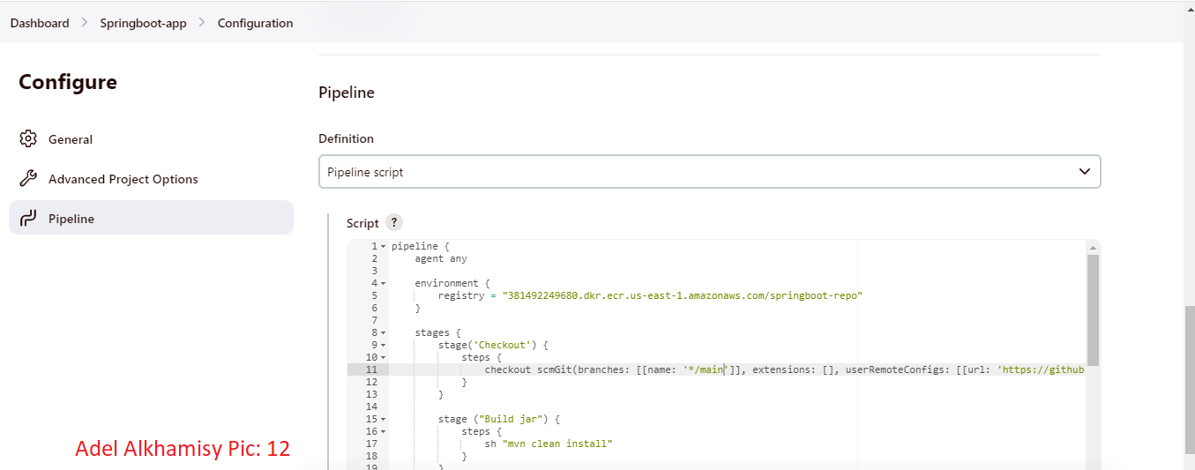

12. Jenkins build pipeline

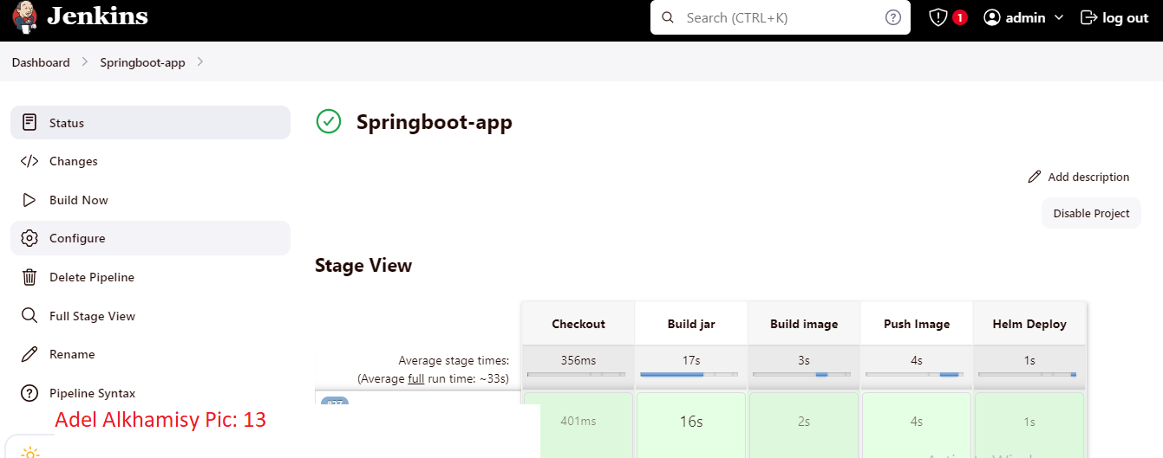

13. List of nodes

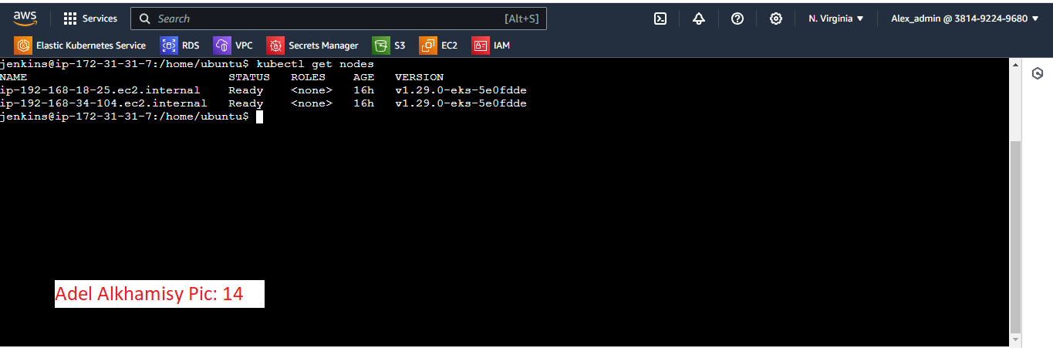

14. List of namespaces

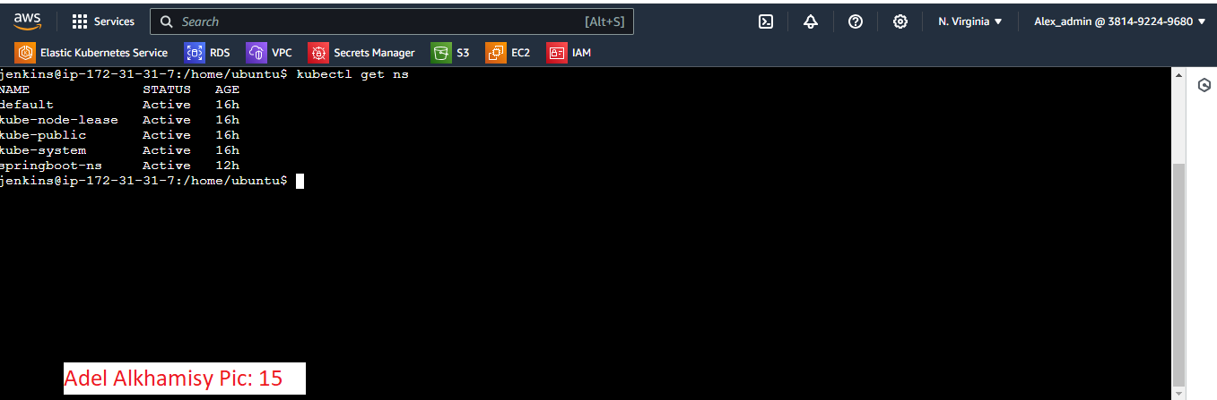

15. Kubernetes pod

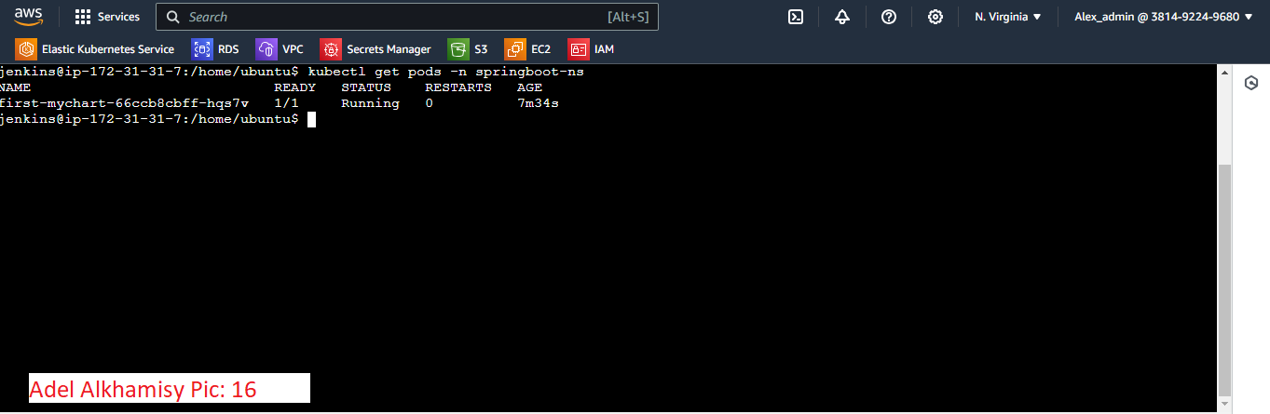

16. Kubernetes service

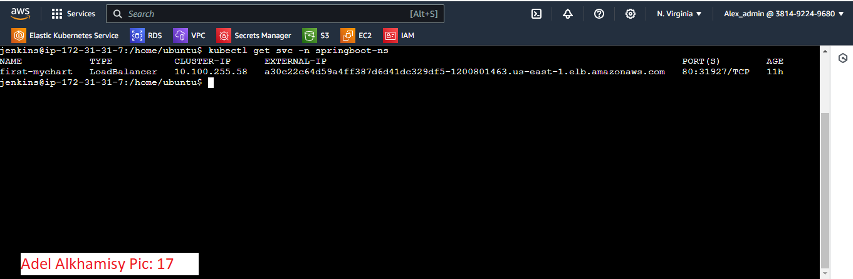

17. Output

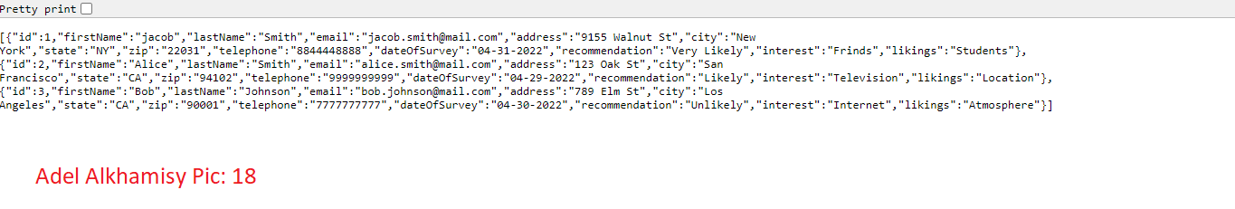

18. GET method

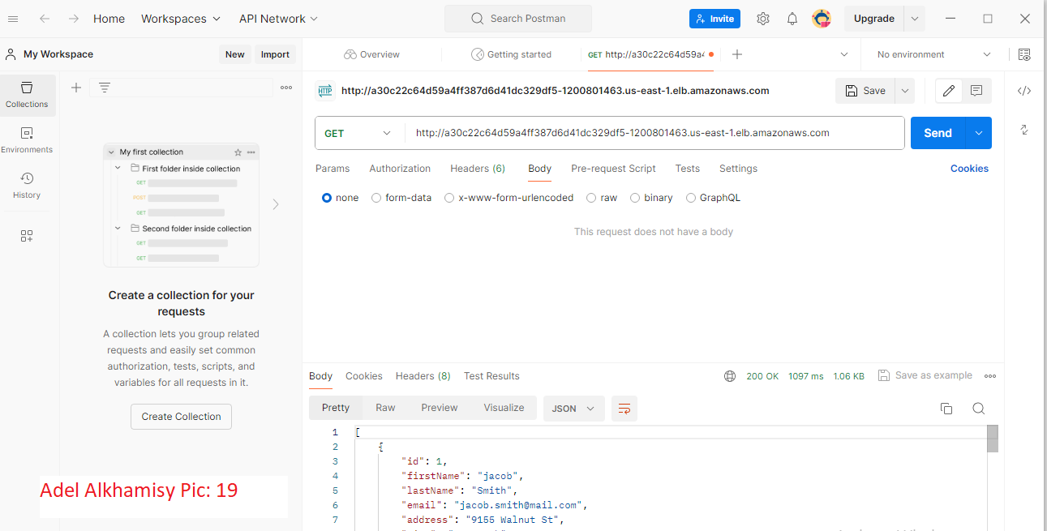

Output:

[

    {

        "id": 1,

        "firstName": "jacob",

        "lastName": "Smith",

        "email": "jacob.smith@mail.com",

        "address": "9155 Walnut St",

        "city": "New York",

        "state": "NY",

        "zip": "22031",

        "telephone": "8844448888",

        "dateOfSurvey": "04-31-2022",

        "recommendation": "Very Likely",

        "interest": "Frinds",

        "likings": "Students"

    },

    {

        "id": 2,

        "firstName": "Alice",

        "lastName": "Smith",

        "email": "alice.smith@mail.com",

        "address": "123 Oak St",

        "city": "San Francisco",

        "state": "CA",

        "zip": "94102",

        "telephone": "9999999999",

        "dateOfSurvey": "04-29-2022",

        "recommendation": "Likely",

        "interest": "Television",

        "likings": "Location"

    },

    {

        "id": 3,

        "firstName": "Bob",

        "lastName": "Johnson",

        "email": "bob.johnson@mail.com",

        "address": "789 Elm St",

        "city": "Los Angeles",

        "state": "CA",

        "zip": "90001",

        "telephone": "7777777777",

        "dateOfSurvey": "04-30-2022",

        "recommendation": "Unlikely",

        "interest": "Internet",

        "likings": "Atmosphere"

    }

]

19. POST method

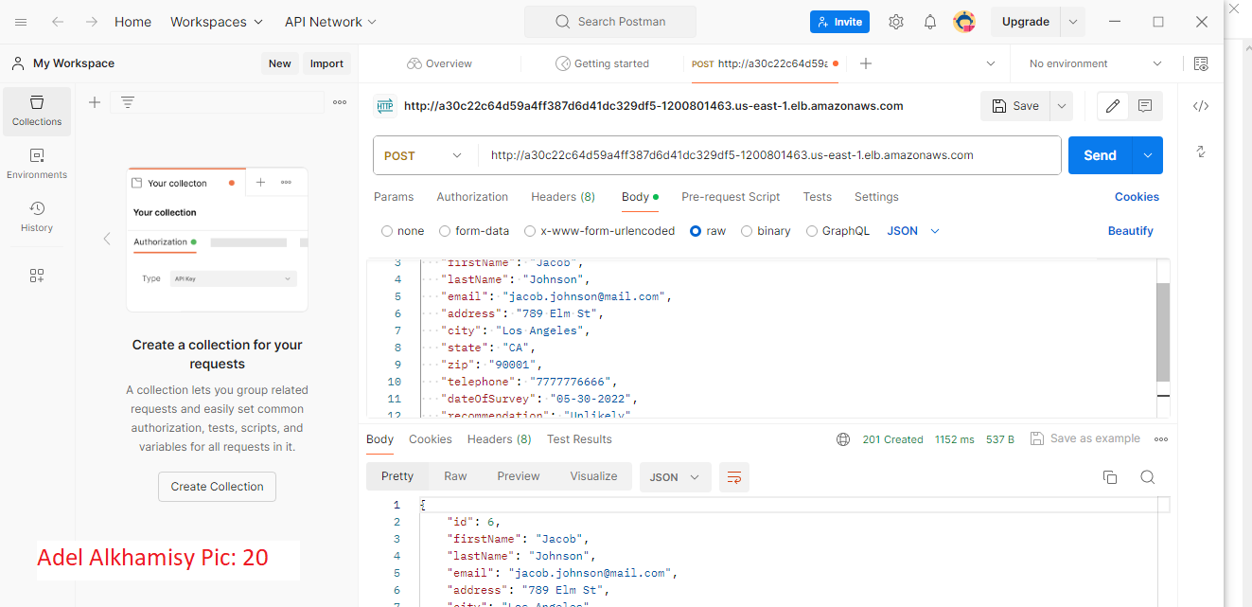

20. DELETE method

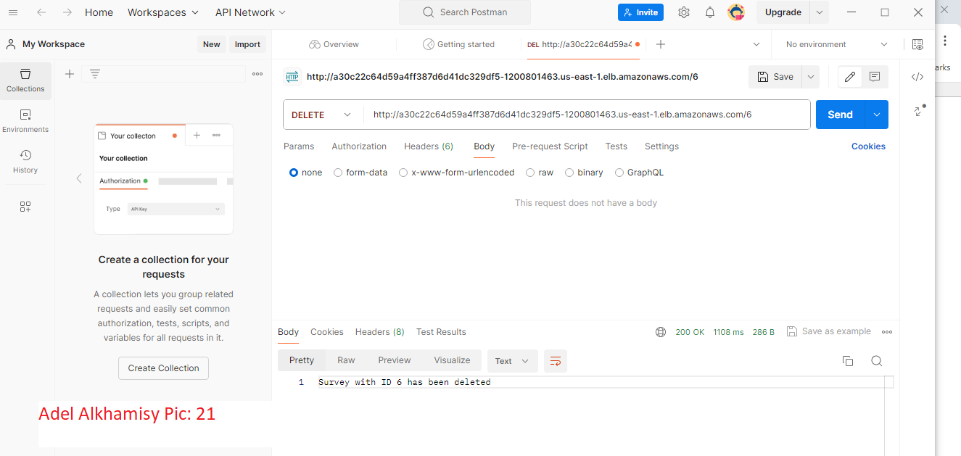

Video URL:

https://www.loom.com/share/09b3f2fd8a9343afa4eaf0ce93c78a9c?sid=29f0f74d-8b25-4418-b0a8-e731154a1168